E Portfolio Guide

REGISTERING

1. Please follow this link to register with the SOHSC Teesside University

E-Portfolio <http://sohsc.tees.ac.uk/MeaVita/Account/mentorregister>

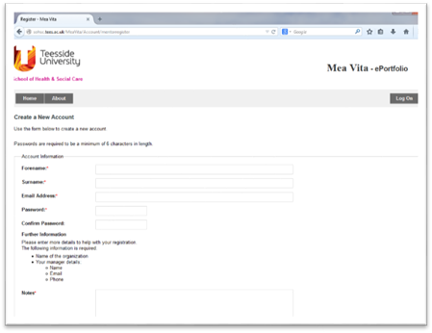

2.    To register you must use your work email address – **failure to do so will cause a delay in the registration process**.

3.    You will be asked to provide the name of the organisation and details of your line manager – their name, email contact and phone number. This information will only be used for verification purposes if necessary.

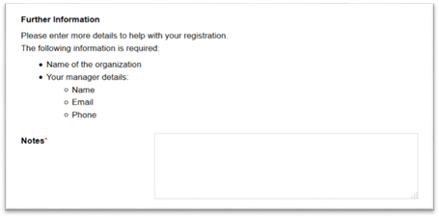

4.     You need to select the subject area relating to the field of practice e.g. **Clinical Psychology**

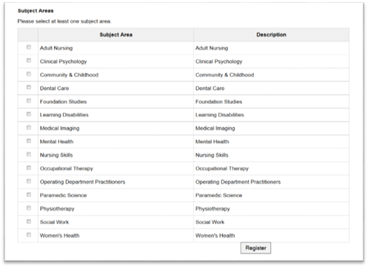

5.    Once you have completed the form click the **Register** button.

6.    You will be logged into the e-Portfolio. If your registration was successful a message will be displayed “You have been successfully registered with the system.” (shown below).

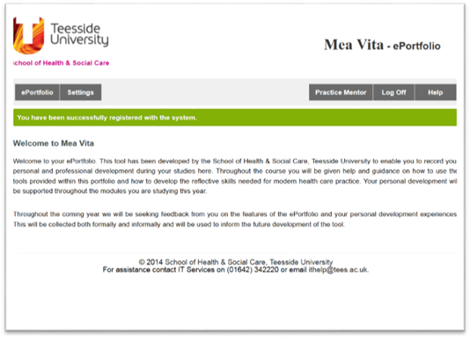

If you do not register with your work email address (or do use an email address for an unrecognised organisation) the following message will be displayed:

**“Your email address is not on the approved list. Your registration as a mentor will need to be approved.**

**You will be unable to verify student competencies until the registration process has been completed.**

**You may, however, use the system as a standard user.”** (as shown below).

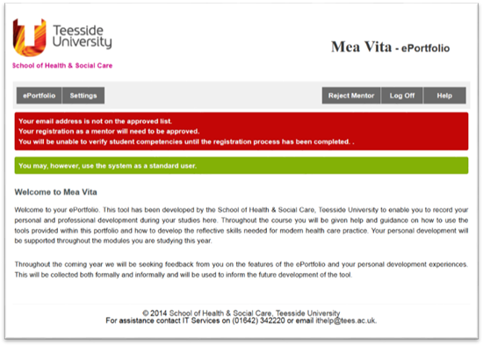

If you encounter any difficulties during the registration process please contact the academic representative whom forwarded this information or Donna Hay on [d.hay@tees.ac.uk](mailto:d.hay@tees.ac.uk).

**Once you have registered successfully with the system please inform the student(s) you are supervising so they can invite you to participate in their e-Portfolio.**

**When you need to access the system for further activities, please use login via the main home page:** <http://sohsc.tees.ac.uk/meavita>

**2.    Additional guidance – issued when students have completed induction**

**Viewing student content**

It is a student’s responsibility to share their essential evidence forms with you.

There are two stages to viewing student content:

1.    Accept a colleague invitation

2.    View Colleague Shares

Note: You not be able to proceed to the next step until the student(s) you are supervising send you a colleague invitation request (you will not receive an email notification this has taken place). Please follow the guidance below to check for and accept a colleague invitation and proceed or remind the student(s) to send you an invitation.

## Accepting Colleague Invitation(s)

The student will send you a **‘Colleague Invitation’** which you must accept to be able to contribute to their assessment documentation . To accept a colleague request follow the guidance below:

1. Click on the **‘Settings’** menu option.

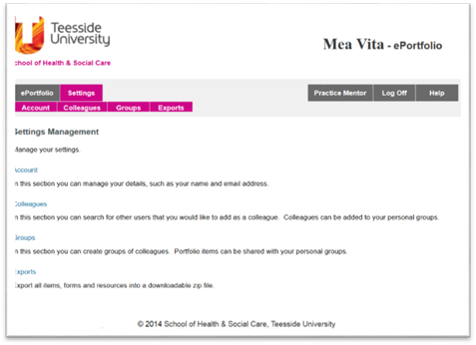

1. Click on the **‘Colleagues’** sub menu option.

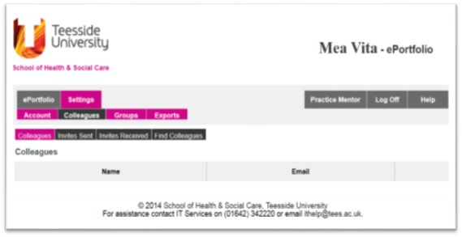

1. Click on the **‘Invites Received’** sub menu option then click the **‘Accept’** option.

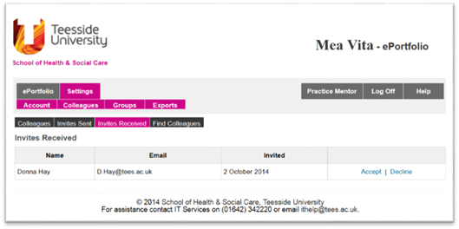

1. You are required to confirm the colleague request by clicking the **‘Accept’** button.

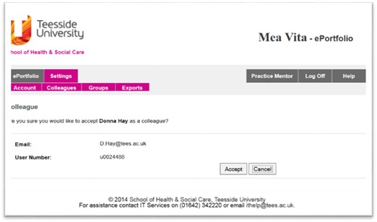

1. Once you have accepted a student colleague request the individual will be listed in your ‘Colleagues’ section.

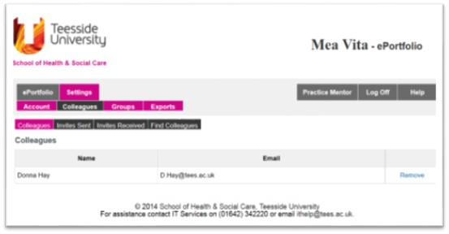

Once you have accepted a student’s colleague invitation it is their responsivity to ensure you can see their essential evidence forms.

## View Colleagues’ Shares

1. From the main ePortfolio menu select **‘Colleagues’ Shares’.**

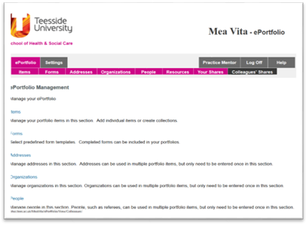

1. Select **‘View Shares**’.

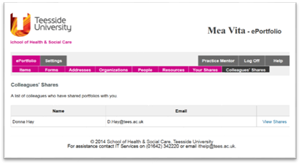

3.    A list of the available shared resources (placement assessment forms etc.) is displayed; select **‘View’** for whichever form you are interested in editing.

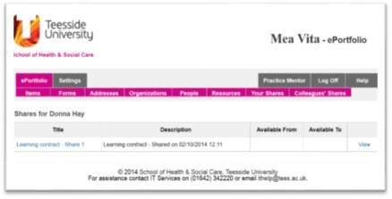

The way you interact with student forms may vary, generally you will be expected to complete (type, click etc.) editable form fields and save completed forms.

Additional guidance can be provided for individual forms, if you require additional support please use the contact details below.

**DONNA HAY**  |  SENIOR TECHNICIAN (E-DEVELOPMENTS)  |  T: + 44 (0) 1642 342748  | [**www.tees.ac.uk**](http://www.tees.ac.uk/)