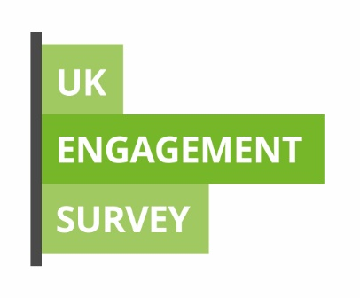

UK Engagement Survey: Student Guide

Frequently Asked Questions

We’re keen to make sure students have the best possible experience while studying at Teesside University. To do that we need to know what you think we are doing well and what we can do better. If you’re thinking about taking part this year, these are the answers to some of the questions students often ask:

What is it?
Why should I take part?
What does it cover?
What happens to the results?
Is it anonymous?
What do I need to do?
Where can I find out more?

What is it?

The UK Engagement Survey (or UKES) is a national survey of students inviting them to comment on their engagement with different kinds of learning activities. The questionnaire takes around 15 minutes to complete.

Why should I take part?

The UK Engagement Survey is your chance to tell us about how you engage with learning on your course, work with others, and take part in the kinds of activities that help you to learn. It is a chance to reflect on how you study and what might help your studies in future. The results also help us make changes that will improve what we do in future and to keep doing the things that are of value. We hope that this will help improve your learning outcomes and those of students like you in the future.

What does it cover?

UKES concentrates on your course and includes:
- critical thinking
- working with other students
- interacting with staff
- course challenge

What happens to the results?

Your feedback is important. We can compare your experience against similar students at other institutions to see if we are supporting your learning as we should. We use the findings to improve our courses and the learning experience for future students.

Is it anonymous?

Your survey response is confidential to the team processing the results and no reporting outside of this team will identify any individual. Any results communicated to teaching staff will be anonymised. The survey asks that any comments you make should not identify yourself or any specific members of staff.

What do I need to do?

You will receive an email with a link to the questionnaire on Friday 26 April. Simply click on the link and complete the online form. The survey is open until Friday 17 April. You can also access the survey via Blackboard.

Where can I find out more?

If you are unsure about anything to do with the survey, or have any difficulty, please contact Academic Registry via surveys@tees.ac.uk.

