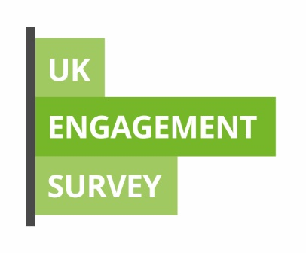

UK Engagement Survey: Staff Guide

The UK Engagement Survey begins at
Teesside University on 26 April 2019.
This guide has been produced to help you support students through the survey process.

What you should tell your students

The UK Engagement Survey is a national survey, co-ordinated by Advance HE. It is carried out by the University and begins here on 26 April and closes on 17 May.

The UK Engagement Survey explores how undergraduate students invest effort, energy and time in their studies. The survey asks students to reflect on their participation in a range of important educational activities, such as critical thinking and collaborating with other students. By going beyond simple measures of satisfaction, UKES is designed to provide more detailed data on how students are encouraged and challenged by their course.

The University and Students’ Union are promoting the survey to help encourage as many eligible students as possible to complete it online and to give their feedback. The more students who complete, the more representative it will be.
The survey is the chance for students to feedback on the extent to which they are engaged with activities that improve learning outcomes. The results help us better support them and focus on activities that will support their learning.

The survey is confidential and the results are made anonymous so that no individual can be identified.

Students will receive a survey link by email from Bristol Online Surveys, and will also be able to access the survey via Blackboard.

Frequently asked questions

How will UKES be carried out?
The survey is carried out by Academic Registry and the questionnaire hosted online by Jisc Online Surveys. On 26 April all research postgraduate students will receive an email from Bristol Online Surveys asking them to complete the survey.

Any students not completing the survey within the first couple of weeks will receive further reminders. The survey will close on 17 May.

What will be asked?
The survey questions are broken down into the following areas:

- Critical thinking
- Learning with others
- Interacting with staff
- Reflecting and connecting
- Course challenge

Students are encouraged to take an overview of the whole course and have an opportunity to comment after each section, as well as at the end of the questionnaire.

What if students don't want to take part?
We strongly encourage students to fill it in as soon as possible because their experience is very important. However, it is not compulsory. Students are able to opt out and can let the University know at any point if they don't want to take part, either by responding to an invitation email or by emailing surveys@tees.ac.uk.

How will I see the results?
The results of institutions aggregated together are published by Advance HE. Institutions own their results and can decide whether to make them public. Detailed results will be available to staff by Academic Registry and disseminated by September 2019. All reporting should provide a fair and balanced picture of provision, and should be directed towards enhancing practice.

More information?

For more information please Academic Registry via surveys@tees.ac.uk.

