Using infographics in your course content

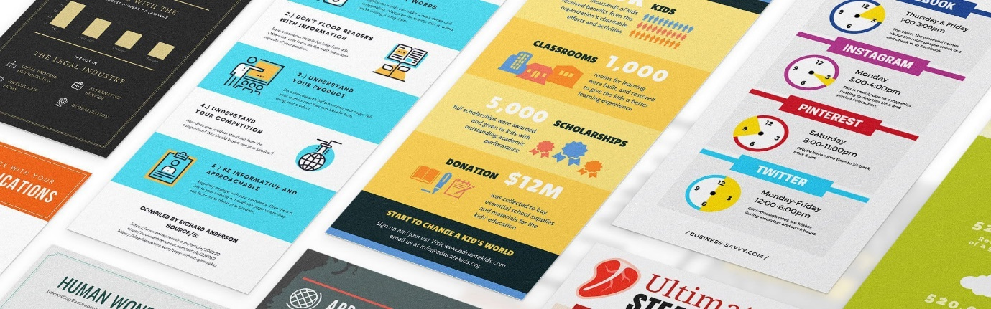

How to create Infographics using Adobe Spark

Before you get started with a design, you will need to select an infographic that best fits your needs and what you want to communicate. Here are the most popular types and how they help you communicate:

- Statistic infographics: Uses visuals or icons to represent the numbers and data points

- Timeline infographics: Helps relay historical events, visualize a project through a deadline, or break down a process

- How-To infographics: Uses illustrations or photos to break a process down into intuitive steps, like Ikea directions!
- Process Chart infographics: Streamlines copy bites one step at a time, with visual support so it’s easy to follow

- Comparison infographics: Uses an A-to-B comparison model to visualize comparisons

Step 1

Create a custom graphic that is 600px wide, by 1400 height. This size fits perfectly in blogs, as well as Pinterest etc. Click on Custom size and input the pixel dimension:

Create the custom size and choose Next:

The canvas will now be set up:

Step 2

We can now add a title and some copy to the infographic by clicking on the Text tool:

You can choose from a number templates:

Select the text type, colour and size for the title:

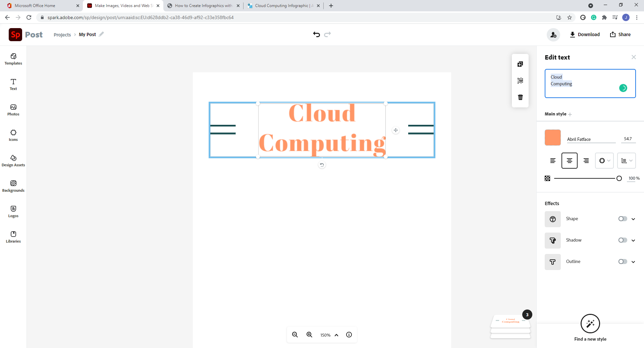

You can then add a range of icons and images from the library:

Step 3

You can continue adding text and library items to create your infographic:
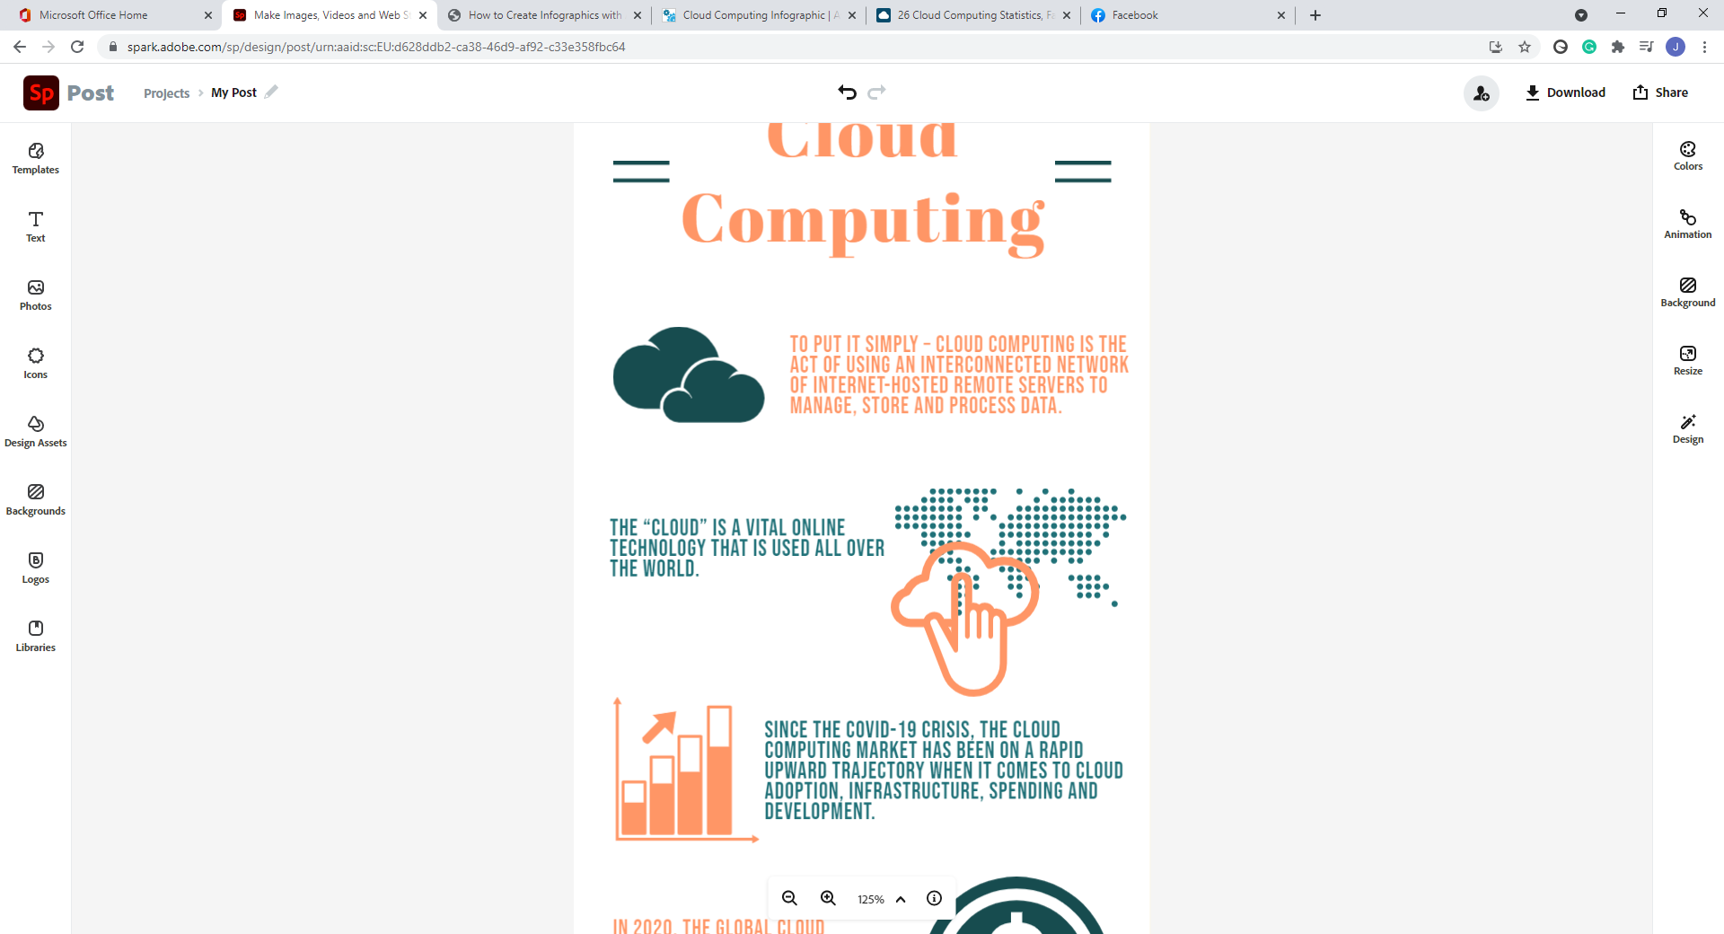

Step 4

When you have completed your infographic you can export it using the Publish button:

You can also download the infographic in a number of file formats which you can then upload to Blackboard or anywhere that accepts graphic image formats.

