

**MODULE EVALUATIONS**

**Completing Module Reflections**

*Module Reflections* are completed by Module Leaders following the closure of the survey, and provide a reflective commentary for students on the results. Module Leaders are invited to consider the *Module Reflections* as a collaborative endeavour amongst the entire teaching team.  
  
The *Module Reflections* are combined with the numerical survey results and emailed directly to students on a specific date. This part of the process is managed by Student Learning & Academic Registry.

1. Access the *Instructor Portal*
2. Identify the appropriate module from the list within the *Closed surveys* tab  
     
     
   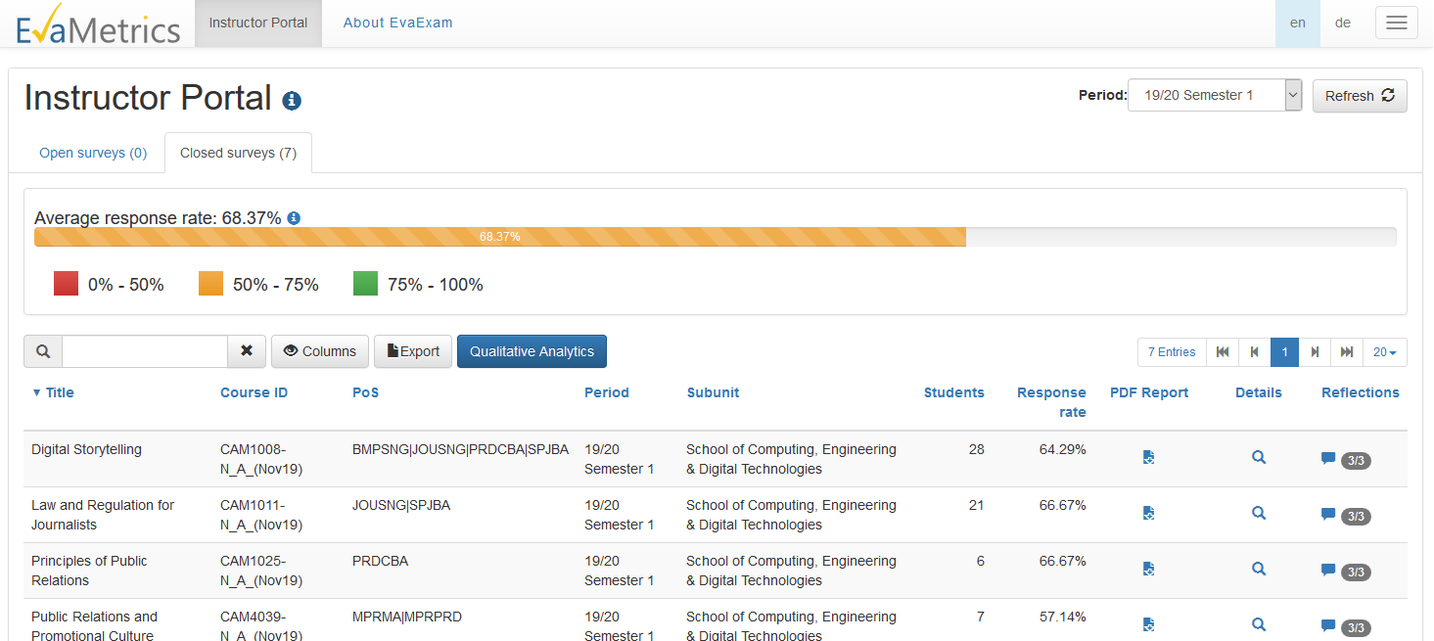
3. Click on the speech bubble in the *Reflections* column
4. A popup screen will appear with boxes for you to enter your *Module Reflections*  
     
   Please check the popup is showing you the *Reflections* entry page (the *Reflections* tab near the top of the popup window should be selected)  
     
     
   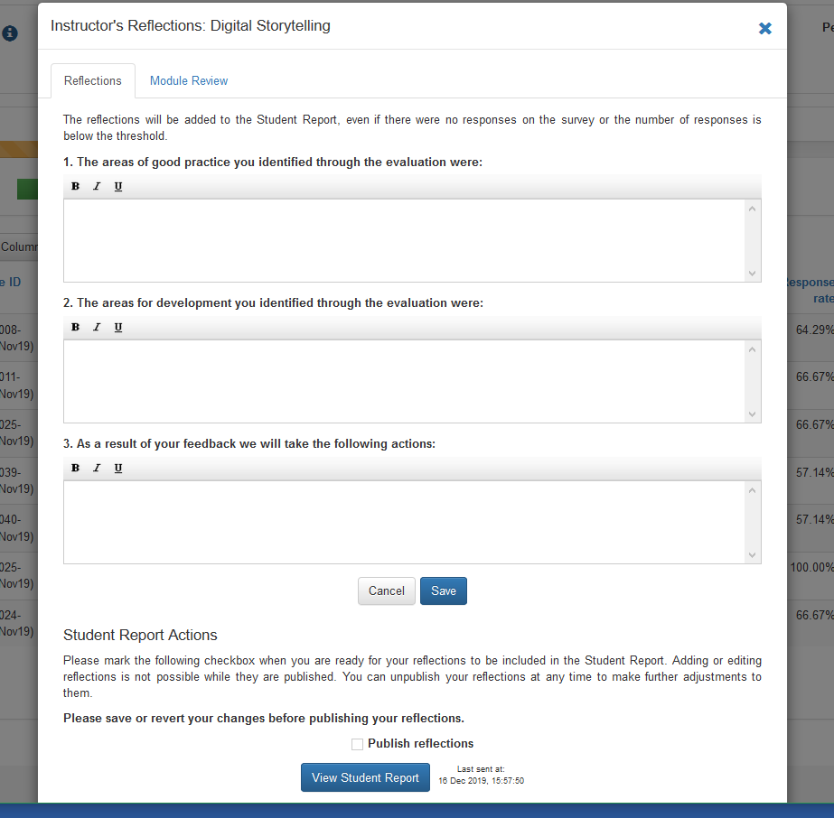
5. Please enter your commentary into the three boxes, using the prompts to guide you
6. When your *Module Reflections* are complete, click *Save*
7. **VERY IMPORTANT**: After clicking *Save*, tick the box next to *Publish Reflections*  
     
   This indicates the *Module Reflections* are complete  
     
     
     
   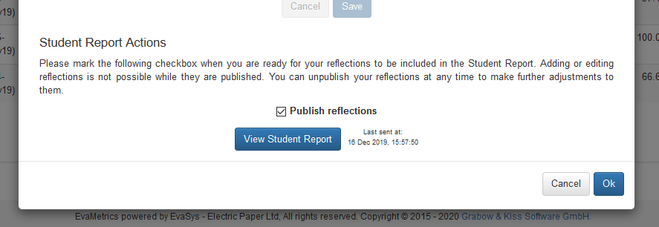
8. Finally, click *Ok* to close the popup window
9. To see the report that will be sent to students, click the *View Student Report* button
10. To make changes to your *Module Reflections,* first untick the *Publish Reflections* box and then make your changes. Don’t forget to re-tick the box when you are finished