

**MODULE EVALUATIONS**

**Accessing the Instructor Portal**

The *Instructor Portal* is used by Module Leaders to monitor live response rates during the survey window and complete *Module Reflections* and *Module Reviews* after the results have been received.

To access the *Instructor Portal*:

1. Go to <https://tees.evasysplus.co.uk/>

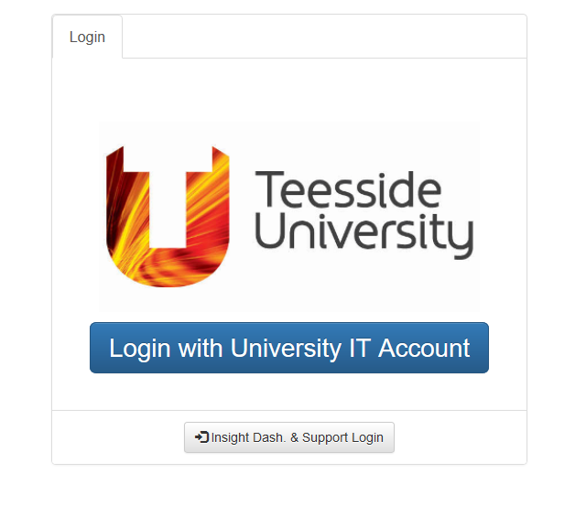

1. Click on *Login with University IT Account*
2. If on campus, the login will proceed automatically
3. If off campus, please enter with your university email address and password where prompted
4. On the landing page, click on the *Instructor Portal* tab in the top left corner.  
     
     
   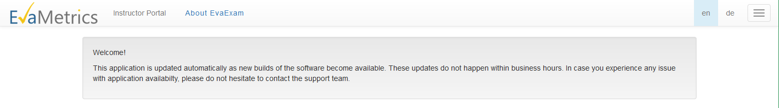
5. The *Instructor Portal* screen will open.  
     
   Click on the *Open surveys* tab (left, middle of the screen) whilst the surveys are taking place to monitor response rates.  
     
   Click on the *Closed surveys* tab after the surveys have closed to complete your *Module Reflections* and *Module Review*.  
     
     
   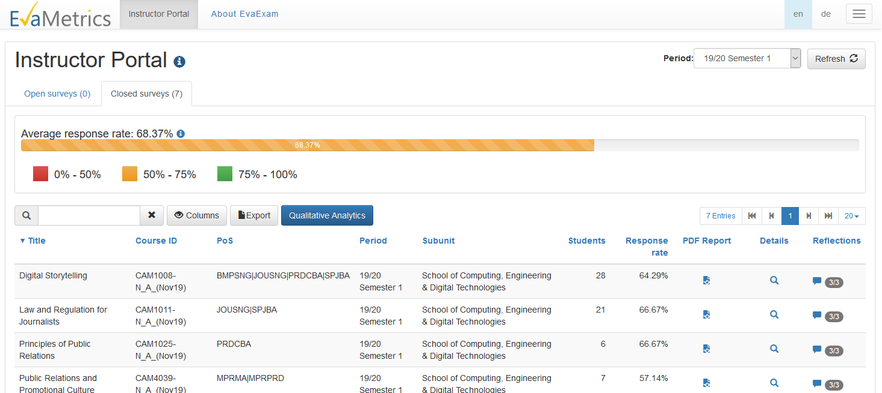

1. If any of your modules are missing, please contact your School Admin Team in the first instance. Module Leader records are downloaded directly from SITS and an update here is probably required.

The website described in this help guide is the one used by university staff to manage and monitor the progress of their module surveys.

If you are looking for the website address which can be given to *students* so they can find and complete their surveys, this is: <https://tees.surveys.evasysplus.co.uk/>.