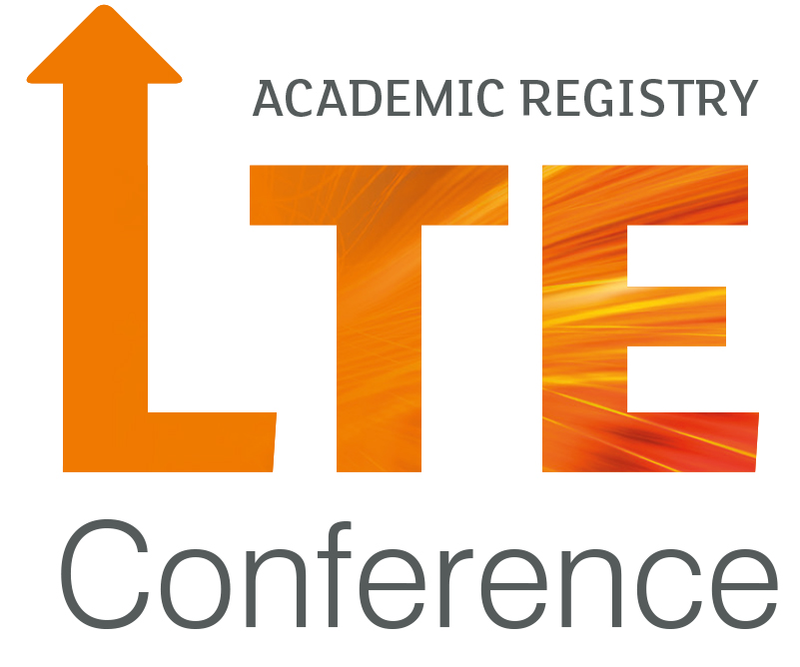

‘Future Facing Learning’

Learning & Teaching Enhancement Conference

3 July 2017

Session Proposal Form

This proposal should be completed and submitted electronically to the conference organisers at academicregistry@tees.ac.uk

Final submission date is Friday 27 April at 17.00 hours.

Lead Presenter Details
Full name(s) | School/Department/College/Unit |  | Job title
Address for correspondence:

E-mail address:

Additional Presenters
Please list all presenters for your session:
Full name(s).
Address for correspondence:

E-mail address:

Session details
Title of session:

Type of session (please tick):
Presentation (30 minutes with Q&A)
Workshop (45 minutes)
Show and Tell (10 minutes)
Poster
Abstract (maximum 250 words)

Session Theme
(please tick):
Future Ready
Socially & Ethically Engaged
Research Active
Globally Connected
Digitally Empowered

Requirements
All rooms will have internet and projection facilities. Please identify any additional resources that you will need.
Car Parking (external presenters only)

