

**MODULE EVALUATIONS**

**Completing Module Reviews**

*Module Reviews* are completed by Module Leaders following the closure of the surveys, and provide a reflective commentary for Course Leaders on the results. Module Leaders are invited to consider the *Module Review* as a collaborative endeavour amongst the entire teaching team.

*Module Reviews* are emailed directly to Course Leaders as part of the completion process (see below). Ultimately, *Module Reviews* will be included in the *Course Journal.*

1. Access the *Instructor Portal*
2. Identify the appropriate module from the list within the *Closed surveys* tab  
     
     
     
   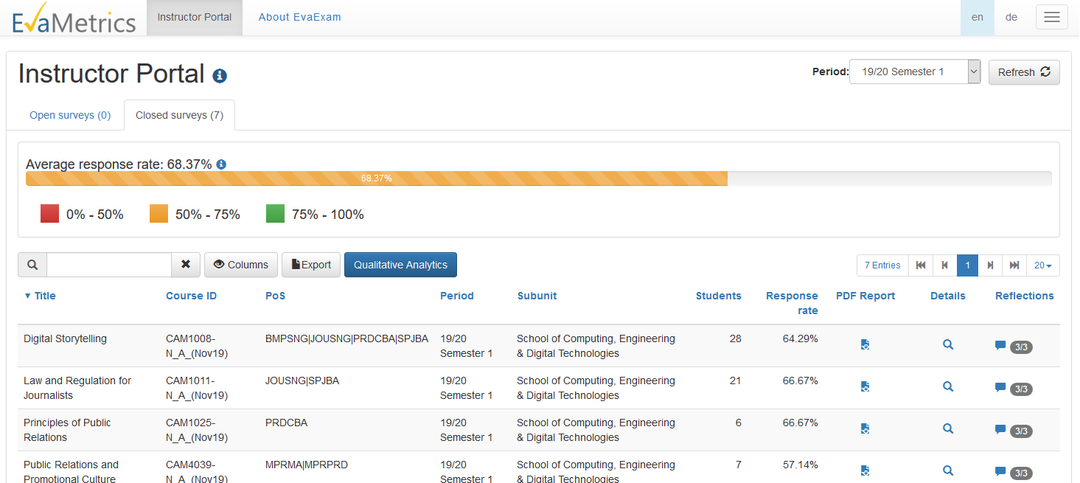
3. Click on the speech bubble in the *Reflections* column
4. A popup window will appear. Click on the *Module Review* tab near the top of the screen.  
     
   The page for entering your *Module Review* will appear  
     
     
     
   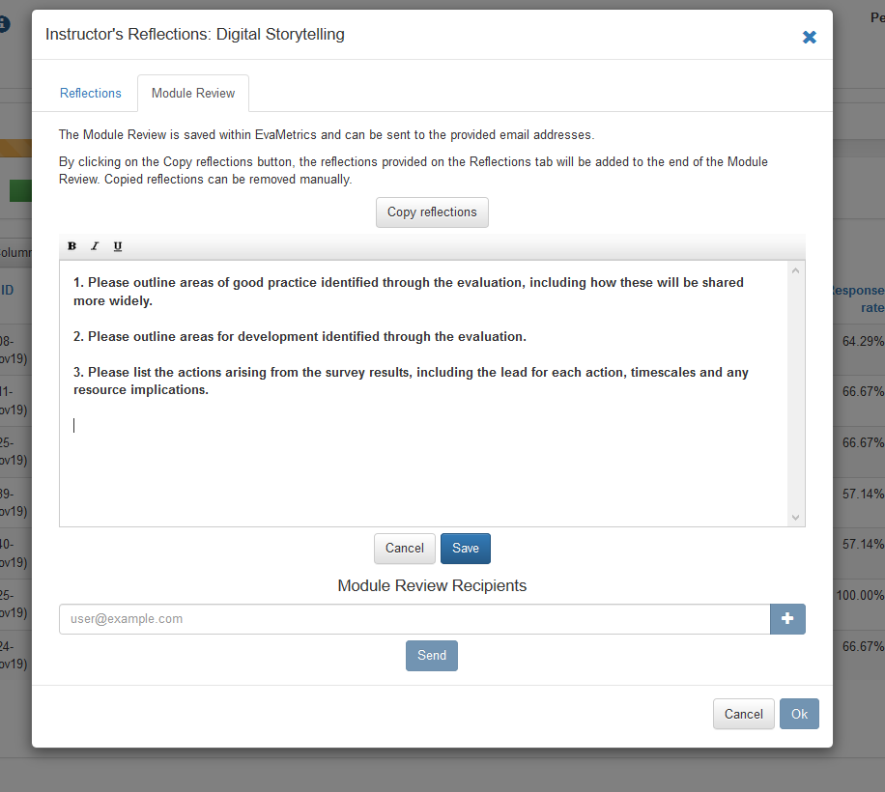
5. Please enter your commentary, using the prompts as a guide
6. Clicking the *Copy reflections* button will copy and paste your student facing *Module Reflections* intothe text box. Whilst this is convenient, we would invite staff to modify the copied text as appropriate for the ultimate destination (the *Course Journal*), perhaps including commentary that is felt to be not appropriate to send to students
7. Click *Save* when finished
8. Next, enter the email address of the Course Leader into the *Module Review Recipients* box. If there is more than one Course Leader, click the ***+*** button to open another box
9. Click *Send* to forward the *Module Review* to the Course Leader/s
10. Finally, click *Ok* to close the window