
Mentor Handbook
For supporting PGCE trainee teachers on TU ITT Courses

2025- 2026

Contents

Contents 2
1. Welcome to Mentoring at Teesside! 4
1.1 Our Vision and Aims 4
1.2 Introducing the Mentoring Team 4
1.3 What You Can Expect from Us 6
1.4 What You Can Expect from Your Mentee 6
2. About Our Courses 8
2.1 Course Information and Programme Structure 8
2.2 DBS Certificate 9
3 Mentoring 10
3.1 Minimum Mentor Profile 10
3.2 Qualities of a Good Mentor 10
3.3 Mentoring Models 11
3.4 Helpful Hints 12
3.5 Target Setting 13
3.6 Roles and Responsibilities 13
4. Mentor Training and Development 16
4.1 Dates of Mentor Training PGCE (Autumn 2025 Start) 18
4.2 Dates of Mentor Training PGCE (Spring 2026 Start) 19
4.3 Dates of Mentor Training - TU Lead Mentors 19
4.4 NASBTT Mentor Development Modules 20
5. Contacts 21
6. Course Information 22
6.1 The TU Curriculum, Directed Tasks and Policies in Practice 22
6.2 ITaP 22
6.3 Documentation 23
6.4 Teaching Practice and PPA 24
6.5 Recording Progress and Making Judgements 25
6.6 Lesson Observations 25
6.7 Weekly Progress Meetings 27
6.8 Tripartite Meetings 28
7. Unsatisfactory Mentoring Situations 29
8. The Professional Practice Portfolio (PPP) 31
9. Weekly Bulletins 32
10. Assignments 33
11. Quality Assurance 33
12. Appendices 35
Appendix A 35
Appendix B 36
Appendix C 38
Appendix D 39
Appendix E 40
Appendix F 45
Appendix G 57
Appendix H 59
Appendix I 61
Appendix J 63
Appendix K 64
Appendix L 65

1. Welcome to Mentoring at Teesside!
A warm welcome from the School of Social Sciences, Humanities and Law to all mentors of trainees on our Initial Teacher Training (ITT) courses. The success of our courses depends on trainees receiving excellent support from experienced colleagues acting as mentors, therefore we appreciate your commitment. The school environment is intended to provide trainee teachers with a realistic and intensive experience of being a teacher and the mentor is a vital professional in the successful training of student teachers.
This Mentor Handbook provides you with essential course information such as, teaching requirements, appraisals, and observations, as well as exploring the roles and responsibilities of a Teesside University (TU) mentor. It will also clarify trainees’ responsibilities and identify specific areas where they may need guidance from their mentors. It should be read alongside each programme’s Course Handbook, which will provide in-depth information about the specific course your trainee is completing. In addition to the mentor handbook, help and support will be available through the mentor training programme, dual observations, tripartite meetings, weekly bulletins, podcasts and the newsletter, alongside regular communication from the TU ITT TEAM.

1.1 Our Vision and Aims
We aim to provide the Tees Valley with informed and resilient trainees who are equipped with the skills and knowledge to be successful as early career teachers and beyond into their teaching careers.
We aim to recruit enthusiastic, committed trainees whose inherent curiosity and creativity as life-long learners empower them to become strong, reflective teachers who strive to continually improve their practice.
Our vision focusses on ensuring children and young people have the highest quality of education, that our schools and colleges can develop strong, inspirational leaders and that, as well as informing our practice with research evidence, we develop our own evidence base for Tees Valley educators.

1.2 Introducing the Mentoring Team
Vikki Leaper – Partnership Mentoring Lead, Lead Mentor, Senior Lecturer in Education
Vikki is an experienced primary educator with over 26 years of teaching across diverse school settings in the Tees Valley. She has held multiple senior leadership roles, including Deputy Head Teacher, Head Teacher, SENDCo, and Advisory Teacher, with over two decades of experience in school leadership. Vikki has also been deeply involved in mentoring, working with a range of Northeast ITT providers to support teacher training, mentoring, and primary-secondary liaison.
At Teesside University, Vikki teaches across PGCE Primary and Secondary, as well as BA Primary programmes. Her core role as Partnership Mentoring Lead involves overseeing the mentoring provision across undergraduate and postgraduate routes. She is committed to making mentoring at TU flexible, accessible, and impactful—enhancing mentor development and directly supporting trainee progress.
Vikki’s research interests focus on mentoring practices, the dynamics of mentoring relationships, and their influence on trainee development.
Jono Thoburn –Lead Mentor, Senior Lecturer in Education
Jono is a Senior Lecturer in Education, with 17 years of teaching experience in secondary schools, during which he held responsibility for teacher training, mentoring and primary liaison and outreach. At Teesside University, Jono teaches primarily on the Secondary PGCE and leads on the Secondary Computing route. In addition to this, he is a Lead Mentor and works closely with Vikki and Sally to deliver high-quality, research-led mentor training to TU’s highly-valued institution-based mentors. He is passionate about making mentor training impactful and accessible whilst minimising mentor workload. Being partially responsible for the design of the professional practice portfolio (PPP), he has designated clinic hours for portfolio support.
Jono’s research interests are around authentic assessment practices and is currently researching the potential role of Podcasting as a form of Authentic Assessment in the age of Generative AI.
Sally Lofts –Lead Mentor, Senior Lecturer in Education
Sally is a secondary school teacher with 19 years of experience teaching. She has worked across a range of different secondary schools in different contexts, throughout the Tees Valley, primarily teaching maths across the range of abilities. At Teesside, she mainly teaches on PGCE Secondary as the maths specialist, as well as BA Primary and PGCE routes. Sally is also admissions tutor for BA primary and secondary PGCE routes alongside being part of the mentoring team with Vikki and Jono.

1.3 What You Can Expect from Us
As a mentor you should expect to receive the full support from the wider Teesside University team.
This will include:
- Access to a variety of mentor training opportunities
- Access to a Mentoring Toolkit, which will include: The Mentor Handbook, Course Handbook, Practice Academic Enhancement Framework (PAEF), the ITT Early Career Framework (ITTECF), as well as a full range of mentor documentation to enable you to contribute to the overall assessment of your trainee’s teaching.
- Regular email contact with the Personal Tutor/Partnership Mentoring Team/Partnership Coordinator
- Weekly bulletins to keep you appraised of TU curriculum content and upcoming events.
- Monthly mentoring podcast to keep you up to date with research, latest developments in mentoring and emerging themes on campus.
- Dual observations to be completed with a member of TU course staff.
- A regular newsletter to keep you informed of key aspects of the wider programme and partnership.
- The opportunity to attend trainee conferences.
- Tripartite communication/meetings involving a member of TU course staff, your trainee, and mentor (face-to-face, on-line platform, telephone or via email)
- The opportunity to feedback regularly on your experiences as a mentor via questionnaire, allowing mentors to influence and improve the mentor experience going forwards and improve efficiency.
- The opportunity to contribute your ideas and perspectives to enhance and develop the programme.

At all times you are welcome to email the Head of Education, Course Leader, or the wider ITT team at Teesside University with any comments, suggestions, queries, or concerns. Contact details of key personnel can be found later in this handbook.

1.4 What You Can Expect from Your Mentee
At Teesside University, our trainees will:

- always behave in a professional manner
- work within the legal and ethical framework and ethos of the profession.
- respect confidentiality when dealing with professional activities.
- seek and respond appropriately to advice from key people, including their Personal Tutor and mentors, regularly discussing their own personal development.
- monitor their professional development using the Practice Academic Enhancement Framework and judge their effectiveness against the PAEF.
- maintain and develop a Professional Practice Portfolio to demonstrate their progress towards gaining QTS.
- store Observation Records, Weekly Progress Proformas, Tripartite Meeting Proformas, End of Placement Reports, as well as reflections on Directed Tasks, and personal reflections within their Professional Practice Portfolio
- in the planning stages, work collaboratively with their Mentors, agree the topic/content and learning outcomes to be taught, listen carefully, and respond to advice.
- make sure that their intended lesson plan and resources are shared with experienced mentors in sufficient time for alterations to be made, if necessary
- engage in wider professional activities as appropriate.

2. About Our Courses
Teacher training courses are demanding. Combining academic study with a substantial teaching practice workload can be challenging for our trainees and requires a high degree of commitment. These are professional courses that are designed to help trainees become the best Early Career Teachers that they can be and to prepare them thoroughly for working in a wide range of educational establishments with a variety of students. That means developing understanding of how to facilitate learning and teaching as well as preparing them for the wider expectations of teaching and training roles.
We expect that trainees will approach our courses, from the outset, in a professional manner and underpinning this course is the ITTECF with a view to meeting The Teachers’ Standards (see appendix A) at the end of the course. On-going formative assessment of trainees throughout the course is against the trainee curriculum, which is underpinned by the ITTECF and therefore the Teachers' Standards. For accurate assessment, we rely on contributions from the trainees’ mentors with regards to progress and professional conduct within the placement setting.
Courses at this level require extensive independent study and reading beyond allocated contact times and trainees are expected to: complete independent reading and research; use online resources; work effectively in collaboration with others; participate in formative and summative assessment activities; take part in a wide range of learning activities and to consistently track and document their development as a professional teacher. Trainees will complete their placement training at different schools over the duration of their course to widen their knowledge and understanding of educational practice.

2.1 Course Information and Programme Structure
Every programme is split into a series of modules which are inextricably interwoven; there will always be an overlap in skills and content. The expectation is that trainees will learn to always apply their learning in a holistic way. For specific detail on Programme Structures and Module Information for each course, please see specific Course Handbooks. Each programme has a specific Course Calendar which can also be found in the Course Handbook.

2.2 DBS Certificate
All trainees will have undergone full DBS checks* prior to being allocated a place on the course. Relevant details will be sent to schools upon placement trainee notification. For DBS checks we ensure that we are meeting the DfE compliance criteria which states:

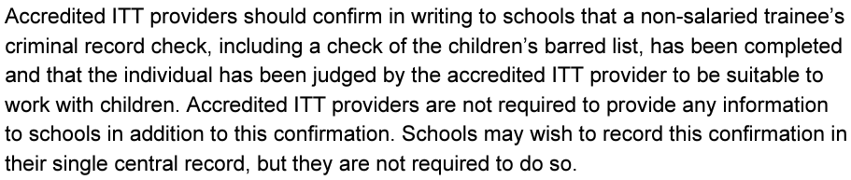

*Satisfactory enhanced Disclosure and Barring Service (DBS) criminal records check which considers the children's barred list and whether a trainee has previously behaved unsuitably for work with children and been removed from a programme or would have been had they not left. Further checks are carried out for international applicants to consider events outside the UK.

In the event a school want to add DBS information to their SCR, we ask trainees to bring their DBS with them on the first day of placement, but we do not share the DBS number.

All trainees are provided with the latest version of the Keeping Children Safe In Education document as part of their Teesside University induction and we complete child protection training as part of the same process.

In addition to this, accredited ITT providers should ensure that all trainee teachers, at the start of their training in any school, are provided with:
- The child protection policy
- The staff behaviour policy (sometimes called code of conduct)
- Information about the role of the Designated Safeguarding Lead (DSL)
We then ask trainees to confirm that they have read and understood this documentation by completing a Policies Proforma (see Appendix J) and uploading into the Professional Practice Portfolio (PPP)

3 Mentoring

3.1 Minimum Mentor Profile
We appreciate that many of the mentors working in partnership have vast experience within education. We ask all schools the beginning of the partnership to complete a Mentor Nomination Form (Appendix B) after having considered the information in the Mentor Person Specification (Appendix C). This will enable us to value the experience and individual expertise of each mentor and identify any specific areas of training that are required. We ask that as a minimum mentor profile, our mentors:

- Are experienced practitioners (at least 2 years’ teaching experience following qualification) We do not allow Early Career Teachers (ECT’s) to mentor our trainees.
- Hold an appropriate teaching qualification (not be a current trainee teacher)
- Are appropriately trained or willing to participate in training to carry out the role effectively.
- Are the person directly in contact with the trainee in the classroom.
- Have sufficient time to fully embrace and carry out the mentor role.
- Can extend learning opportunities, provide access to resources, offer support, and positively challenge trainees in their approach to daily tasks so that maximum progress is made.

3.2 Qualities of a Good Mentor
At a very simple level, mentoring is: ‘the relationship between two parties, in which one party (the mentor) guides the other (the mentee) through a period of change and towards an agreed objective or assists them to become acquainted with a new situation.” (Kay and Hinds, 2012, p.20) However, at TU we have very high expectations for all stakeholders within our partnerships, including ourselves.

Our mentors should have:
- A desire to help others to develop their potential.
- An open mind and a desire to learn and grow continuously themselves.
- A wish to give something back: to use accumulated experience and wisdom to help the next generation of teachers succeed.
- Time, commitment, and sensitivity for the role
- The ability to build effective, professional relationships, built upon mutual trust and respect.
- Up-to-date subject and pedagogical knowledge and understanding of educational initiatives.
- Flexibility, creativity, and problem-solving skills
- A desire to motivate, encourage and empower others.
- Enthusiasm for their practice and the desire to share it with others.

As Wright (2010) indicates, the mentor must be much more than simply an experienced teacher, as the more experienced and expert we become “the less we need to think explicitly and analytically about what we’re doing” (Wright 2010, p6). Effective mentors need to disseminate their own professional practice for the trainee teacher who may be overwhelmed by the complexities inherent in working in the education sector for the first time.

Above all, ‘a mentor has to be approachable…A mentor should not ask (mentees) to do something that they wouldn’t be prepared to do themselves. Equally, they should prompt you with questions that make you think, rather than give answers’ (Hughes 2021, p.3 -4). Therefore, a mentor should scaffold, support, and steer trainee teachers, building their confidence and empowering them to be the best they can be.

3.3 Mentoring Models
The following models may provide with additional information on mentoring styles and frameworks:
Model | Description | Where to read more about it
Clutterbuck (2002) | Discusses four basic styles of helping: directive, non-directive, stretching, nurturing | Wallace, S. and Gravells, J. (2007) Mentoring, 2nd Ed, Exeter: Learning Matters
The Grow Model | Provides a framework for coaching by considering: Goal, Reality, Options/Obstacles and Will/Way Forward | Fletcher, S. and Mullen, C. (2012) SAGE Handbook of Mentoring and Coaching in Education, London: Sage
Malthouse and Roffey-Barentsen | Cycle based on the experience, reflection, professional practice, and action planning | Malthouse, R. and Roffey-Barentsen, J. (2013) Reflective Practice in Education and Training, Exeter: Learning Matters
Kolb (1984) + Honey and Mumford (1992) | Based on concrete experience, observation and reflection, abstract conceptualisation, active experimentation | Wallace, S. and Gravells, J. (2007) Mentoring, 2nd Ed, Exeter: Learning Matters

3.4 Helpful Hints
When providing feedback to trainees a useful rule is to keep it SIMPLE
Sensitive | Remember that constructive criticism, no matter how well meaning, can be difficult to listen to.
Issue related | Maintain focus – don’t get side tracked.
Meaningful | Relate all areas of discussion to personal development and professional standards.
Prompt | Don’t leave it too long after the observation of teaching practice.
Listen | Listen to the mentee’s analysis and use prompt questions to help them develop effective reflective skills.
Easy to understand | Don’t complicate things and illustrate with examples where appropriate

(Adapted from Wallace and Gravells, 2007, p. 74)
When giving feedback/feed-forward  Do | When giving feedback/feed-forward  Don’t
Create the right conditions. It should take place in an atmosphere of trust and real rapport | Launch into a barrage of criticism in order to get it out of the way as quickly as possible
Ask questions to enable them to assess themselves | Interrupt
Begin with two or three positive things which you want to praise | Be so general as to make it worthless
Follow with something that would make the performance even better next time | Criticise the individual on a personal level- stick to observations of behaviour and performance
Be specific – give examples and reasons | Be aloof
Ask for their response to what you have said | Deny them the chance to share their views and feelings
Be clear about what the consequences of not improving are | Brush over feelings
Recognise what contribution you may have made to any problems | Just think the ‘praise sandwich’ will do it for you
Make clear your positive desire to help resolve any problems, taking a ‘can do’ approach | Take a ‘just get on with it’ attitude
Be sensitive | See it as a chance to show off your powers of observation
Finish with an overall positive comment; consider getting them to summarise | End with negativity or expect that they have remembered everything that you have said
Encourage self-evaluation by asking questions rather than making statements | Make it a one-way discussion
Be honest and accurate | Exaggerate
Focus on what can be changed rather than what cannot | Be insensitive to factors beyond their control
Make suggestions | Give instructions

3.5 Target Setting
When creating targets with trainees, we ask that mentors keep them SMART:
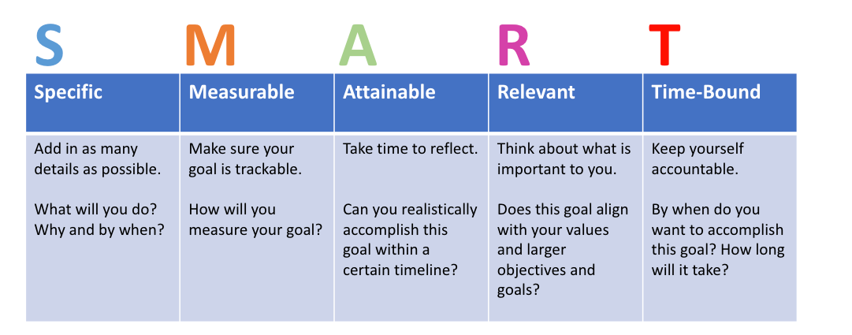
To support mentors with SMART target setting, there is PowerPoint Guidance available in the Teams folder.

3.6 Roles and Responsibilities

The core purpose of a mentor is:
- To establish trusting relationships, model high standards of practice, and understand how to support trainees through initial teacher training.
- To support trainees to develop their own teaching practice, set high expectations of all pupils and meet their needs.
- To set high professional standards and induct the trainee to understand their role and responsibilities as a teacher.
- To continue to develop their own professional knowledge, skills and understanding and invest time in developing good working relationships with Teesside University and others within the partnership.

Whilst on placement, working alongside our trainees on a day-to-day basis is the Mentor. Larger schools may also require support from the Head Teacher, or an appropriate person in the Senior Leadership Team, to coordinate a number of mentors and trainees.
At TU, we also have Lead Mentors, comprising the TU Mentoring Team, in addition to other identified Lead Mentors who work in conjunction with the University to assist delivery of mentor curriculum and ITAP.

The Mentor will support students in their placement experience by fulfilling the following roles and responsibilities:

- Take an active role in the Mentor Network, attending all meetings to ensure that they are aware of, and trained for, their role and responsibilities as well as sharing best practice and developing strategies for supporting trainees.
- Plan trainee structured activity using the ITT Early Career Framework (ITTECF) and the wider curriculum plan for ITT courses as outlined in Programme Documentation.
- Ensure that the processes and procedures outlined in Programme Documentation are adhered to during the placement.
- Support the trainee on a day-to-day basis, both professionally and pastorally.
- Ensure that dedicated mentoring time is given to the trainee – 90 minutes targeted support per week.
- Ensure they have a weekly progress meeting with the trainee during the placement, completing the Weekly Progress Meeting Proforma.
- Observe the trainee informally and formally and give regular feedback.
- Engage in mentor training, either synchronously or asynchronously, and demonstrate impact in trainees’ placement practice.
- Liaise with the trainee’s TU Personal Tutor regarding their progress in teaching practice.
- Act as a critical friend.
- Aid reflection on specific Directed Tasks
- Provide the trainee with advice and guidance as necessary, promoting the development of independent skills and resilience.
- Support the trainee to engage with up-to-date research and use evidence-informed approaches, delivering CPD.
- Encourage the trainee to use appropriate documentation e.g., lesson plans, schemes of work, resources, and individual learning plans for students, in the planning and delivery of teaching sessions.
- Assess the trainee both informally and formally and collaborate with the trainee to co-create SMART targets to drive progress.
- Ensure that all relevant paperwork, evaluations, reports, and QA outcomes are returned to the University.
- Attend tripartite meetings alongside the mentee, and a member of TU staff.
- Contribute to the development of the trainee’s Professional Practice Portfolio
- Write End of Placement Reports and set appropriate SMART targets for Placement 2 / ECT years.
- Attend a transition meeting with the Placement Two Mentor in preparation for the second placement, to outline the trainees’ progress and targets, ensuring smooth transition and continued progress.
- Support trainees to manage workload and plan teaching and development activities with well-being in mind.
- Partake in quality assurance and moderation processes as required by the University.
- Keep in regular contact with the TU Personal Tutor, Course Leader or Partnership Mentor Team and alert them quickly to any concerns regarding the trainee.
- Fully communicate with all TU teaching staff to ensure an effective partnership.

This list is not meant to be all-encompassing but is a guide to some of the key mentoring activities that would benefit students’ progress on the course.

A Lead Mentor will hold responsibility for

- oversight, supervision, and quality assurance of mentoring provision in schools
- design and delivery of training for mentors
- tracking the number of hours of training undertaken by mentors, as part of the assurance of the general mentor grant funding,
- close working with trainees during intensive training and practice and the design of such elements
- oversight of trainee progress throughout the year and identification of interventions or modifications where required.
- in addition, providers may delegate other appropriate functions to lead mentors; for example, the opportunity to work on the design of training curricula relevant to the lead mentor’s expertise.
- providing evidence of training undertaken by mentors, for example by completing and sharing a register with the placement school and DfE
- designing detailed, high-quality lead mentor training

In addition to this, we ask that a Senior Member of Staff within school who is responsible for ITT, is available for support and quality assurance purposes. As ITT Coordinator, there is no requirement to complete mentor training.

Please note: If any of these core responsibilities are not fulfilled, this results in a trainee not getting the expected support and the trainee may have problems reaching their potential and readiness to move onto the next stage/placement in their programme. It could also result in the termination of the partnership. If you are having difficulties, it is important to let the university know as soon as possible. We can, and will, always provide support if needed.

4. Mentor Training and Development
The University curricula fully aligns with and underpins Professional Practice on all programme routes. Theoretical content is further developed in professional practice with progressive weekly directed tasks. These tasks are communicated to all Mentors on a weekly basis through the bulletin, are frontloaded in the student Professional Practice Portfolio (PPP) and are structured to support taught content in a progressive approach. Mentor development training is aligned to university curricula and designed and structured to develop mentors’ knowledge and understanding, within the ITTECF core areas, so that trainees are fully supported within placement. We ask that mentors use the knowledge and skills gained within their mentor training in practice so that it has direct impact with their trainees. Some TU Mentor training comprises NASBTT Mentoring Modules, which are underpinned by the National Standards for School- based ITT Mentors and designed using evidence-based principles to best fit the needs of Teesside University trainees.

As part of the Partnership Agreement and as required by the DfE it is a mentor’s responsibility to ensure that they engage with all mentor training. The purpose of the training is to:
- ensure mentors are familiar with TU programme documentation.
- ensure mentors are familiar with the role of the mentor as required by this programme.
- ensure mentors are kept abreast of educational research and evidence-based practice.
- provide mentors with a platform to discuss the programme, the mentor process and contribute to its development.
- ensure a consistent understanding of the observation process for trainees.
- understand mentors’ invaluable role in supporting the development of specialist knowledge and pedagogy.
We understand that mentors are making a big commitment, and there are therefore several ways that training can be completed. These are outlined below:

Type of training | Who and where
University mentor training sessions | There will be a schedule of training sessions which will take place ‘live’ online, and some will be offered asynchronously. Although we strongly urge you to take part in the ‘live’ sessions so that you can network with other mentors, these sessions will also be available offline in the Mentor Teams site. Sessions are not recorded.
Dual observation | All mentors will complete a dual observation with a member of the delivery team as part of our Quality Assurance process. This forms part of the mentor training for everyone.
Additional training at the time of the dual observation | One-to-one mentor training can be provided at the time of dual observations, or at the request of the mentor.
Bulletins, tripartite meetings, asynchronous reading, voluntary NASBTT modules | These activities are all considered when calculating mentor training time.

All training is compulsory for mentors. We are always happy to work with individual mentors to ensure that mentor training is accessible to all and there is the flexibility to complete training asynchronously. We set our mentor training dates at the beginning of the academic year, as we understand the need to have dates early to aid school planning. Therefore, all the dates for Mentor Training for 2025- 2026 are already set. CPD may need to be evidenced to access DfE Mentor funding, so mentors should ensure their attendance is logged at training and claim any assessed NASBTT badges or certificates.
Which Mentor Training Route Am I?
The guide below gives you an idea of which mentor training route you should be on, depending upon your experience.

Mentoring Experience | Training Route | Training Contents
I Have Mentored with TU in the last 2 years | Top Up Programme | - Face-to-face induction / Networking event.  - Engagement with top-up training (changes to programme / curriculum / paperwork) – Asynchronous + optional drop in.
I am new to mentoring with TU but have completed training at other institutions | Standard TU Mentor Training | - Face-to-face induction / Networking event.  - Training Programme designed to cover TU-specific training + access to NASBTT Mentor Development Modules. 4 online meetings through the year + asynchronous content  - Full support as and when you need it from Mentoring Team. Fast turnaround for mentoring enquiries.  - All training content made available via the Teams site.
I am brand new to mentoring | Standard TU Mentor Training + support / basic certification | - Face-to-face induction / Networking event.  - Training Programme designed to cover TU-specific training + relevant NASBTT Introducing and Embedding modules.  - 4 online training sessions through the year + asynchronous content.  - Extra support as and when you need it from the Mentoring Team. Fast turnaround for mentoring enquiries. No problem too small!  - TU Mentoring Certification.
I have mentored with TU before and want to develop further as part of my CPD | Advanced Mentoring Programme | - Face-to-face induction / Networking event.  - Bespoke programme of NASBTT Enhancing Modules to suit your Professional Development Journey  - TU Advanced Mentoring Certification

The Advanced Mentoring Programme is designed for those mentors who have already completed 20 hours of TU mentor training. Mentors are invited to develop their CPD further by following an ‘advanced’ mentoring programme. This is an optional route and mentors will be emailed information by the Mentoring Team to offer this route.

4.1 Dates of Mentor Training PGCE (Autumn 2025 Start)
Date | Who to Attend? | Where
Wednesday 17th September | PGCE Mentors | TU Campus, 4pm
Thursday 2nd October | PGCE Mentors | Online via Teams 4pm
Thursday 23rd October | PGCE Mentors | Online via Teams 4pm
Thursday 20th November | PGCE Mentors | Online via Teams 4pm
Thursday 11th December | PGCE Mentors | ASYNCHRONOUS
w/b Monday 26th January | Placement 1 and Placement 2 Mentors, as well as trainees | Transition Meeting online via Teams
Thursday 5th March | PGCE Mentors | ASYNCHRONOUS
Thursday 24th April | PGCE Mentors | Online via Teams 4pm
Thursday 4th June | PGCE Mentors | ASYNCHRONOUS

4.2 Dates of Mentor Training PGCE (Spring 2026 Start)

Date | Who to Attend? | Where
Wednesday 21st January | PGCE January Mentors | TU Campus 4pm
w/b Monday 26th January | Placement 1 and Placement 2 Mentors, as well as trainees | Transition Meeting online via Teams
Thursday 29th January | PGCE Mentors | Online via Teams
Thursday 19th February | PGCE Mentors | Online via Teams
Thursday 5th March | PGCE Mentors | ASYNCHRONOUS
Thursday 12th March | PGCE Mentors | ASYNCHRONOUS
Thursday 23rd April | PGCE Mentors | ASYNCHRONOUS
Thursday 14th May | PGCE Mentors | Online via Teams
Thursday 4th June | PGCE Mentors | ASYNCHRONOUS

4.3 Dates of Mentor Training - TU Lead Mentors
Date | Who to Attend? | Where
Wednesday 17th September | Lead Mentors | TU Campus, 4pm
September | Lead Mentors | ASYNCHRONOUS
October | Lead Mentors | ASYNCHRONOUS
November | Lead Mentors | ASYNCHRONOUS
December | Lead Mentors | ASYNCHRONOUS
w/b Monday 26th January | Lead Mentors | Preparation and Transition Meeting - Online
January | Lead Mentors | ASYNCHRONOUS
March | Lead Mentors | ASYNCHRONOUS
April | Lead Mentors | ASYNCHRONOUS

Mentor Training sessions begin at 4pm, and the Partnership Mentor Team will be online after the training for individual concerns or support. Attendance at each training session is registered and we will communicate with those mentors who persistently do not engage to offer support. This could result in termination of partnerships.

4.4 NASBTT Mentor Development Modules
We work in partnership with NASBTT, a partner in the Chartered College of Teaching, and therefore TU Mentors receive access to the Mentor Development Modules (MDM’s). Each module is bite-sized on an area of focus, can be accessed flexibly, and tailored to meet individual mentor’s needs, being pitched at three levels to reflect mentor experience and development need – introducing, embedding, and refining. At the end of each module a badge can be awarded, following a short assessment, which count towards the mentor training requirement, as directed by the DfE.



5. Contacts
Contact | Role | Email Address
Sam Eason | Head of Education | s.eason@tees.ac.uk
Clare Sutton | Course Leader PGCE Primary  Senior Lecturer in Education  Primary Specialist | c.sutton@tees.ac.uk
Lindsey Tennant- Williams | Course Leader PGCE Secondary  English Subject Specialist | L.Tennant-Williams@tees.ac.uk
Jane Knowlson | Course Leader BA Primary (Hons) Education  Senior Lecturer in Education  Lead Mentor | j.knowlson@tees.ac.uk
Ollie Harness | Partnership Lead  Senior Lecturer in Education  Geography Subject Specialist | o.harness@tees.ac.uk
Vikki Leaper | Partnership Mentoring Lead  Senior Lecturer in Education  Primary Specialist | v.leaper@tees.ac.uk
Jono Thoburn | Senior Lecturer in Education  Computing Subject Specialist  Partnership Lead Mentor | j.thoburn@tees.ac.uk
Claire Moody | Senior Lecturer in Education  STEM Subject Specialist | c.moody@tees.ac.uk
Christina Snaith | Senior Lecturer in Education  History Subject Specialist | c.snaith@tees.ac.uk
Sally Lofts | Senior Lecturer in Education  Maths Subject Specialist  Lead Mentor | s.lofts@tees.ac.uk
Vanessa Cockin | Senior Lecturer in Education  Design Technology Subject Specialist  ITaP Lead | v.cockin@tees.ac.uk
Andrea Brown | Senior Lecturer in Education  Art and Design Subject Specialist  Lead Mentor  ITaP Lead | andrea.brown@tees.ac.uk
Chloe Tait | Partnership Coordinator | chloe.tait@tees.ac.uk

6. Course Information

6.1 The TU Curriculum, Directed Tasks and Policies in Practice
It is of paramount importance that all mentors understand the TU curriculum to support effectively with placement practice. The TU University Curriculum is shared with mentors during induction and subsequent training. Information about our curriculum is also available in the Mentor Teams site. We value and seek mentor feedback on our curriculum. By mastering the trainee curriculum, trainees will meet the Teachers' Standards. Our curriculum is underpinned by the ITT Early Career Framework (ITTECF) (ITTECF) and weekly directed tasks are created to satisfy curriculum requirements whilst in placement, thereby linking theory to practice. These directed tasks can be found in Course Handbooks. Directed tasks will also be emailed to mentors on a weekly basis via the Weekly Bulletin so that mentors know which focussed activities trainees will need to complete the following week within placement.

There will be many school policies that mentors will want trainees to read, understand and follow in practice. There are certain policies that our trainees MUST read and understand, as part of their Directed Tasks. These are Keeping Children Safe In Education, Child Protection Policy and Staff Behaviour Policy. We ask trainees to sign a Policy Proforma (see Appendix J) to state that they have read and understood these policies. This completed proforma should be placed in their Professional Practice Portfolio as evidence.

6.2 ITaP
Intensive training and practice (ITaP) is a specific and focused element of the teacher training curriculum. It is intended to help consolidate trainees’ knowledge of key evidence-based principles for effective teaching, and to enable them to practise their application and integration into their developing professional practice. TU Mentors will be given ITAP-specific training during their induction and at appropriate points through the academic year. DfE requirements are as follows:

- Foundational curriculum aspects sequenced within the wider curriculum.
- Isolates and presents “particular content points” and provides a demonstration of them by an expert. These are “then practised by trainees in the intensive setting”.
- Consolidate trainees’ understanding of how the evidence base should shape teaching practice.
- Increasing coherence between taught theory and its practice in schools.

Our PGCE ITAP schedule for 2025-2026 is as follows:

ITAP FOCUS - PGCE
Cycle | Date | Focus | Students included
Cycle 1 - Week 6 | Monday 6th – Friday 11th October. | Teaching routines that create an  effective learning environment | Secondary/Primary PGCE
Cycle 2 – Week 12 | Monday 5th – Friday 9th January | Embedding decoding and encoding in early reading and spelling | Secondary/Primary PGCE
Cycle 3 - Week 19 | Monday 12th – Friday 16th January | Identifying pupils who need new content broken down and providing targeted and small group support. | Secondary/Primary PGCE
Cycle 4 – Week 27 | Mon 2nd – Friday 6th March | High-quality verbal feedback and live marking at the point of learning | Secondary/Primary PGCE

6.3 Documentation
All Documentation needed to support your trainee can be found in the Appendices. Documents that mentors will need during the placement are:
- Mentor Observation Proforma + Guidance
- TU Tutor Observation + Tripartite
- Lesson Planning Format + Guidance (not compulsory to use, if required)
- Weekly Progress Report
- End of Placement Reports (need to be saved as PDFs)
- Cause for Concern Form
- Practice Academic Enhancement Framework (PAEF).

These will also be made available to mentors, as part of the TU Mentor Toolkit, which is in the Mentor Teams Site, as well as the blog, https://blogs.tees.ac.uk/ite-support/ to which all mentors will have access.

6.4 Teaching Practice and PPA
Trainees will undertake significant teaching practice placements that will form an integral part of their training as a teacher. Each Course Handbook, and Observation and Teaching Load Guide, will outline expectations in terms of teaching hours. We favour a gradual increase across the placement, with maximum 10-12 hours per week by the end of Placement 1. There is a statutory requirement that by the end of Placement 2, trainees should have completed a six-week block comprising teaching hours commensurate with 80% of a Full-Time teacher’s timetable – This works out at around 18 hours per week. Trainee teachers should not be used for covering classes in the absence of the class teacher, nor for cover supervision. This guidance can be found in the documentation section of the Mentor Teams Site, along with a lesson plan format and guidance (See Appendix E). While not compulsory to use, TU students are strongly encouraged to use this to formalise their planning. This helps the mentor see what is trying to be achieved in the lesson and could provide a basis for post-lesson discussion.
As trainees’ teaching hours increase, they should have some PPA time outside of the classroom. PPA can be in the form of planning time with their mentors or independent planning time. All PPA must be taken in school (not at home). Therefore, for each hour of teaching we suggest the following for PGCE trainees:
- 0-4 hours - 1 hour
- 5-8 hours - 2 hours
- 9-10 hours - 3 hours
- 11-13 hours - 4 hours
- 14- 16 hours - 5 hours
- 17- 18 hours - 6 hours
This is for guidance only – please feel free to contact your trainee’s Personal Tutor if further clarification is required.
During their time on placement, the mentor will provide frequent verbal and written feedback linked to the development of the trainee as a practitioner. Mentors play a vital role in contributing towards the development of the trainees’ subject specialist knowledge and pedagogy, helping to frame that within the context of a teaching environment with learners of different levels and with different needs. During their teaching practice, trainees will continue to be supported by TU staff, in particular their TU Personal Tutor. The Personal Tutor will work alongside mentors to observe, deliver training, give support, and facilitate tripartite meetings.
Learning and development on placement will be supported by:
- Observations of experienced practitioners
- Modelling of lesson planning and creation of curriculum plans
- Formal and informal observations of the trainees’ teaching
- Working with, and alongside, experienced colleagues
- Attendance of CPD activities and other institutional events
- Regular reflection on practice
- Regular meetings with mentors

Throughout the course, trainees will track and manage progression as a teacher through the development of a detailed and substantial Professional Practice Portfolio. This will demonstrate the progress of the trainee and will inform the basis of individual vivas at the end of placements. Trainees will be guided towards further suitable resources that may support their development as a teacher for example, internet resources, media outlets, employability guidance, examination boards and government policy documentation.

6.5 Recording Progress and Making Judgements
All records of a trainee’s progress are to be evidenced in their Professional Practice Portfolio.

6.6 Lesson Observations
A key aspect of being a mentor is conducting regular observations of trainees. Lesson observations should only be carried out by trained mentors. The mentor should make informal observations of trainees on a weekly basis. It would be beneficial to trainees if mentors could fill out a Mentor Observation Form (see Appendix F for proforma and guidance) as this makes evidencing progress in their portfolio more efficient, though informal notes can also be used. Formal TU Personal Tutor observation schedule and teaching load guidance for PGCE is shared in the Observation Schedule and Teaching Load document, available on the Teams site. All Weekly Progress Reports and Observation Records should be given to the trainee and placed within their Professional Practice Portfolio.
Before an observation the student teacher should give mentors:
- A copy of the observation proforma with the target(s) from their previous observation or weekly progression meeting. Mentors need to agree the focus of the lesson observation and the targets that are set for the trainee in this observation. The trainee should have completed this part of the observation form before the lesson observation.
- A copy of their lesson plan (48 hours prior)
- Any relevant resources
- A copy of any written assessments they are carrying out with the pupils.

For recording progress and making judgements about trainees’ progress, there are two documents to use:
- ITT Early Career Framework (ITTECF) (ITTECF)
- Practice and Academic Enhancement Framework document (PAEF)

Practice Academic Enhancement Framework (PAEF) is for guidance on assessing your trainee throughout their placement. The PAEF is used for judging your trainee’s performance throughout their placement. The PAEF can be used as a tool to assess progress, inform target setting and make judgements throughout (see Appendices I). It is important to note that even though the Teachers’ Standards are used for experienced teachers, trainees do not have the same level of experience, skills, and knowledge. Therefore, it is only the PAEF that is used to judge progress throughout placement experiences. The Teachers’ Standards are used to assess in the final observation for PGCE trainees at the end of placement practice, in addition to the final summative Viva at the end of the course. All judgements should be made in relation to wider placement practice, NOT individual lessons. Evidence in the following areas should be considered:

1. Consistently competent teaching
2. Impact on pupil learning and progress
3. Evidence collated in practice (including tracking and recording pupil progress)
4. Reflection and self-evaluation.

6.7 Weekly Progress Meetings

Weekly Progress meetings should take place between the Mentor and trainee and a Weekly Progress Report should be completed where SMART targets are set. Lessons should not be graded but the Practice Academic Enhancement Framework should be referred to in order to help identify strengths and areas for improvement (See Appendix K). As the trainee approaches their final assessment, they should judge progress towards meeting the Teachers’ Standards at the end of the course.

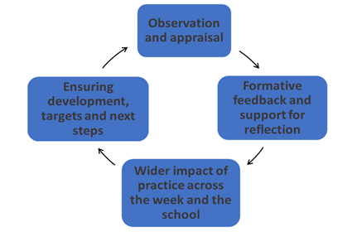

The weekly progress meeting should include the following:

- A check of the trainees’ mental health and wellbeing
- Review and feedback of any informal and formal observations conducted that week to offer further reflection and thoughts as needed.
- Discussion of current targets to see if the student has made progress or addressed these.
- Identification of strengths, either ongoing or developing
- Evidence could be provided which could include examples of children’s work, marking and feedback, lesson evaluations, assessments, and children’s portfolios.
- SMART targets agreed and set for the following week, or continued on from previous weeks, including strategies to support these.
- Completion of the Weekly Progress Report Proforma (see Appendix G)

6.8 Tripartite Meetings
Tripartite meetings provide a valuable opportunity for a mentor to discuss mentee’s strengths, provide examples of what trainees have achieved, how they are working towards course outcomes and where they need further support. It also enables mentors to keep in touch with the trainee’s TU Personal Tutor and to set joint SMART targets for further development.

Tripartite meetings will take place, generally after every formal observation between the trainee, TU Personal Tutor, and Mentor. In this meeting, the trainee’s progress is discussed, SMART targets agreed and a Tripartite Meeting Proforma is completed by TU Staff (see Appendix F). Information about the number of tripartite meetings is in each Course Handbook. However, more observations and meetings could take place depending on the individual need and progress of the trainee and if there is cause for concern. Trainees are encouraged to reflect on the content and outcomes of these meetings and log their reflections as part of their Professional Practice Portfolio.

End of Placement Report/ End of Final Placement Report
Towards the end of each placement, an End of Placement Report (See Appendix I) is written by the Mentor and discussed with the trainee. During these meetings a discussion takes place around the trainee’s development, ensuring that they are making links between theory, taught content, and their own practice. Targets are set for the second placement, or their ECT Years. The following items need to be discussed and recorded:
- summative comments based upon key areas of learning, with targeted areas if applicable.
- SMART Targets set to inform their second placement or ECT years.
- a summative comment written by the trainee about their overall progress during the whole placement.
There are separate reports for end of placements one and two, due to the end of placement two being assessed against the Teachers’ Standards. This report will inform their ECT years.

Where specific issues arise, mentors are more than welcome to arrange additional meetings with TU Staff to discuss solutions and identify additional support.

7. Unsatisfactory Mentoring Situations
Mentors who, at any point in the placement, have concerns that a trainee is not responding sufficiently to on-going professional dialogue and not progressing appropriately towards achieving or exceeding their expected outcomes are requested to follow the key procedure outlined below:

- In the first instance, problems may be discussed with the trainee’s TU Personal Tutor. This is an informal route, and most issues are resolved at this level.
- Contact the Course Leader. If discussion with TU Personal Tutor does not resolve the issue, contact either: l.tennant-williams@tees.ac.uk (Secondary PGCE) or c.sutton@tees.ac.uk (Primary PGCE).
- Contact the Partnership Mentor Team: v.leaper@tees.ac.uk or j.thoburn@tees.ac.uk
- Contact the Partnership Lead: o.harness@tees.ac.uk
- Contact the Head of Education: s.eason@tees.ac.uk

Possible Courses of Action:
- Discuss the concern and identify specific targets with an agreed date when they need to be met.
- Articulate success strategies with the trainee and with dates expected for completion.
- Monitor progress and give support where needed.
- Complete a Cause for Concern proforma if needed or if the concern persists (see Appendix I)

Examples of possible Cause for Concern situations:
- Despite a reminder, the trainee’s planning is not ready for the mentor to check and sign off before delivery.
- Poor attendance at placement school
- Weak subject knowledge that impedes children’s learning, which has been discussed and observed on more than one occasion. Support strategies have resulted in no progress made.
- A trainee’s teaching is consistently requiring improvement to become good and there is lack of progress made, despite intervention.
- There are safeguarding concerns.
- Lack of professionalism / unprofessional behaviours

Deferred and Failed School Experiences

A deferred placement is when there is an unexpected halt to the placement, but the trainee was making the expected progress. This may be because:
- the trainee has become ill and is unable to meet the demands of the school experience for the rest of the placement.
- there has been a change in personal circumstances which means the trainee is unable to focus on the placement at the present time.

Failed placements could be a result of:
- an inability to make progress towards meeting the Teachers' Standards at the end of the course.
- an inability to reflect upon practice, to listen to and act upon advice provided from experienced professionals.
- the trainee withdrawing from the placement without any consultation with the university.
- a serious professional issue of misconduct, such as the health and safety of children has been compromised.

A school experience will be terminated early and judged to be a failed placement when a trainee’s performance is judged by the school to be detrimental to the effective running of the school, or the learning, well-being and/or health and safety of pupils. This should be done in consultation with the Course Leader, Head of Education and Head Teacher at the school.
Where the student teacher feels there is a problem with the mentoring relationship, it is expected that they will bring it to the attention of their Personal Tutor or Course Leader to facilitate a resolution of the problem. Support will be given to the trainee by University Staff. The Mentoring Team will support both the trainee and the mentor.

Unsatisfactory Placements
Should the school fail to meet the partnership responsibilities during the placement as outlined in the School Partnership Agreement, the School’s Head Teacher, or appropriate member of the Senior Leadership Team, will be contacted, and concerns should be discussed in a professional dialogue. Decisions to discontinue any partnerships will be at the discretion of the Head of Education and Partnership Coordinator.

8. The Professional Practice Portfolio (PPP)
The Professional Practice Portfolio is designed to track, monitor, and evidence the trainee’s learning journey from the start to the end of the course. It will explicitly demonstrate all aspects of the trainee’s progress as a teacher. The PPP includes mentor documentation, evidence towards achieving the Teachers’ Standards and reflections on a variety of aspects linked to trainees’ teaching. Although trainees are required to complete all the sections by themselves, they may benefit from professional discussions with the mentor around the topics and may need access to specific resources.

The following diagram outlines the structure of the PPP:

The Professional Practice Portfolio (PPP) will include, but is not limited to:
- Action planning and tracking of progress, expectations, maths, English and e-learning.
- Observations of established practitioners and peers
- Original resources, lesson plans and other content
- Lesson observation documents from Mentors and Tutor
- Evidence of CPD
- Critiques of lesson plans, curriculum plans and assessment methods.
- Records of Mentor, Tutorial and Tripartite meetings
- Weekly Directed Tasks and evidence that they have been completed.

These, and other, sources will be used to provide:
- Evidence for the summative assessment of progress towards the Teachers’ Standards using the PAEF.

9. Weekly Bulletins
Bulletins will be sent out weekly by the Partnership Mentor Lead, whilst the trainee is on placement. Bulletins contain details of directed tasks to be completed by the trainee the following week, as well as any other communication needed and contact details.

10. Assignments
There are several assignments which trainees must pass to gain their QTS. Full details of each assignment can be found in each programme’s Course Handbook.

11. Quality Assurance

The impact of mentor training should be evidenced and seen in the quality of mentoring in placement schools, reflected in the standard of completed documentation in the PPP and in the standard of trainee teachers at the end of the programme. Quality Assurance takes place through monitoring and evaluating all aspects of provision, to ensure compliance with the DfE ITT criteria and requirements for ITT/Ofsted ITT framework. The TU Mentoring team also participate in Quality Assurance processes for NASBTT.

Effective communication is an essential part of the school mentor and TU partnership. All observations will always be completed in person by TU Personal Tutors. Tripartite meetings will be carried out in person by TU Personal Tutors where possible. But at times, if needed, meetings may take place through Microsoft Teams. All TU Personal Tutors are expected to contact school mentors when observation windows open to introduce themselves and arrange a mutually convenient time for trainees’ first observations. This first observation will be a dual one, between TU staff and mentors and is the basis of quality assurance. If there are any mentoring concerns that arise within this observation, TU staff will communicate with the TU Partnership Lead, who will liaise with the mentor within the placement school and offer mentoring support.
As part of our Quality Assurance processes, we monitor:

- The quality of Weekly Progress Reports
- The individual targets set and subsequent action plans.
- The quality of mentor feedback in tripartite meetings
- Observations and written proformas
- End of Placement Reports
- Trainee and mentor feedback

As an ITT provider, we have robust:

- interview policy and procedures
- assessment and moderation procedures
- selection and deselection of schools’ procedures
- course reviews, including analysis of intakes, withdrawal rates, trainees’ destinations, analysis of external examiners’ reports.

As part of our monitoring and quality assurance, we may ask that ITT Coordinators partake in quality assurance observations and provide feedback to TU via Microsoft forms. This process aims to not be onerous and add to workload. Also, as part of our monitoring and quality assurance, there are External Examiners for each programme.

Thank you for taking the time to read this Mentor Handbook. We look forward to working in partnership with you!

The TU ITT Mentoring Team

Disclaimer

The information contained in this Mentoring Handbook is, as far as possible, accurate and up-to-date at the time of writing. This handbook will be kept up-to-date by the Partnership Mentoring Lead.

The express permission of Teesside University must be obtained to reproduce any, or all of this publication, other than for personal use or for those purposes permitted by law.

12. Appendices

Appendix A
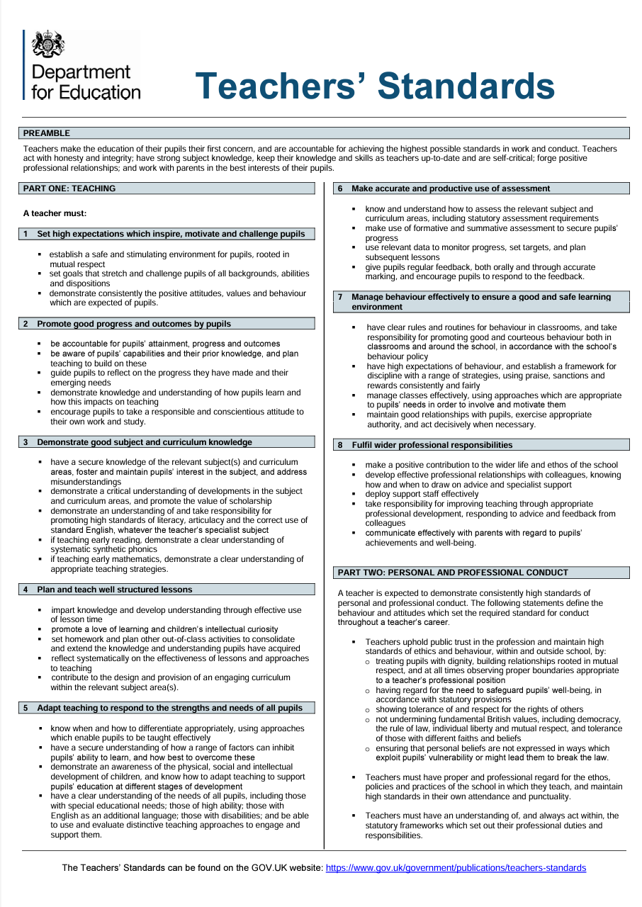

Appendix B


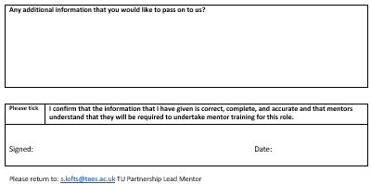

Appendix C


Appendix D


Appendix E
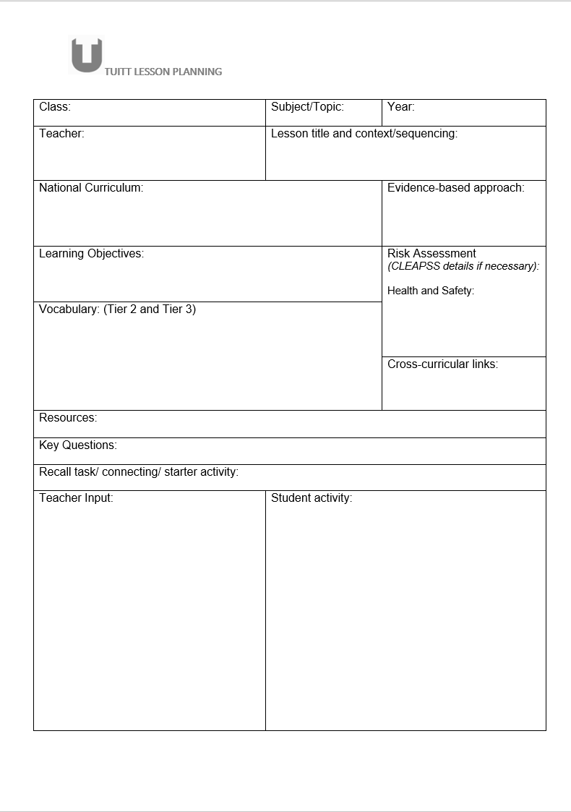


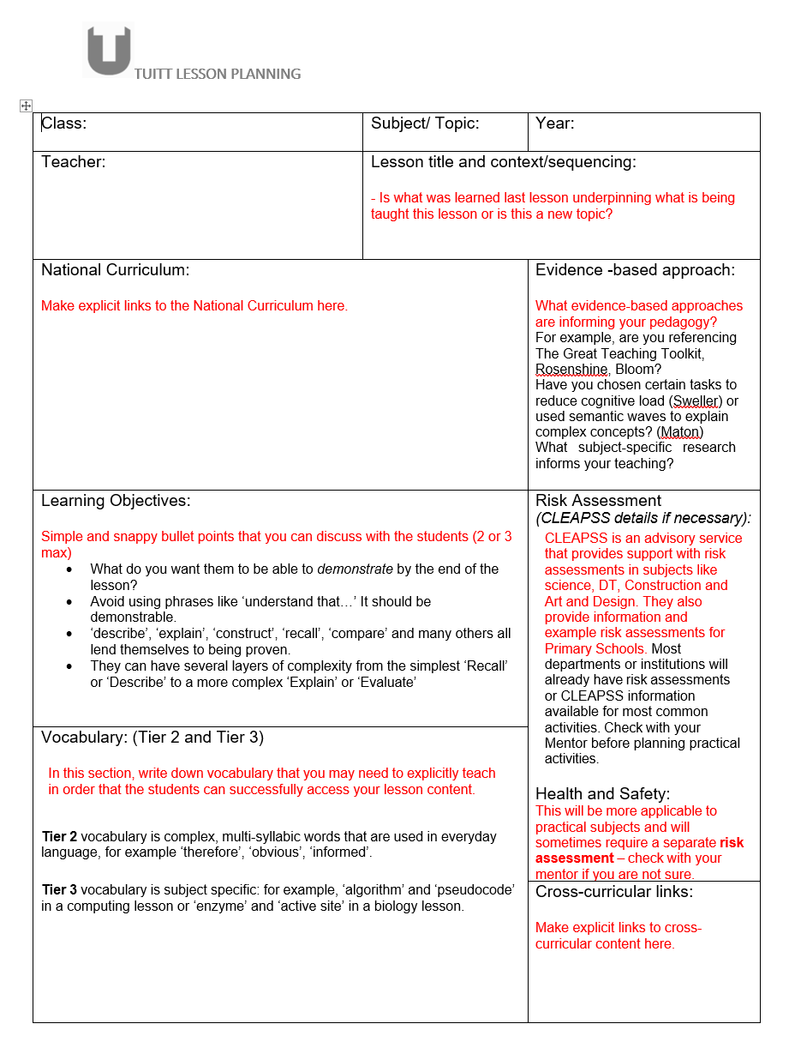

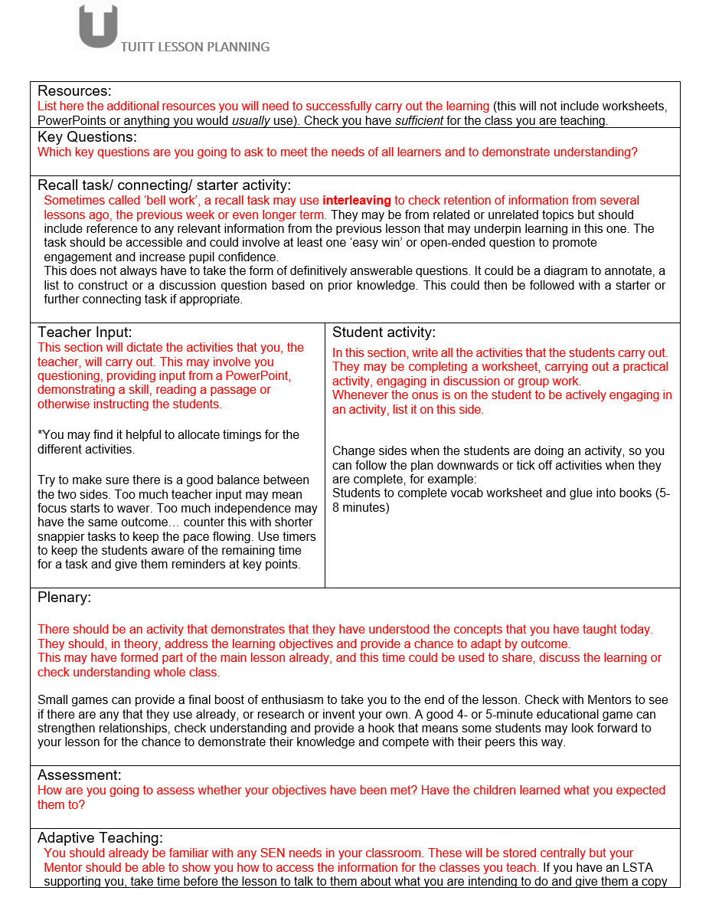



Appendix F





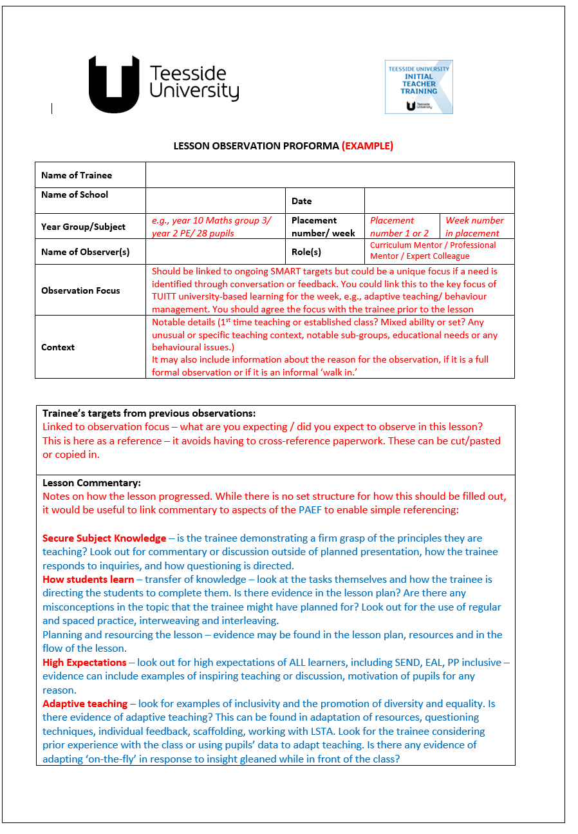
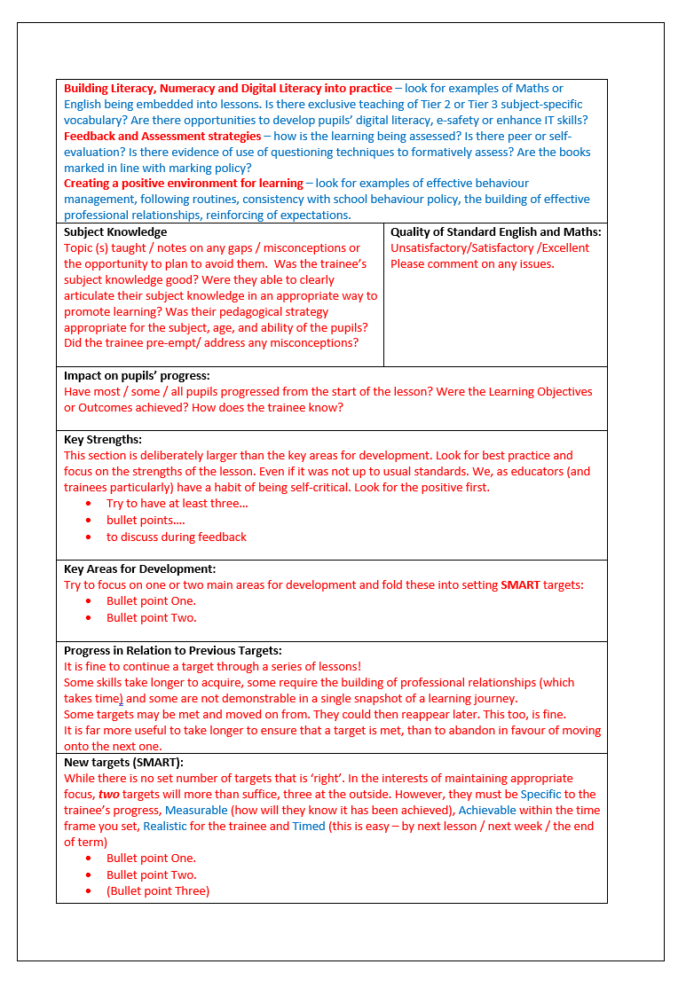
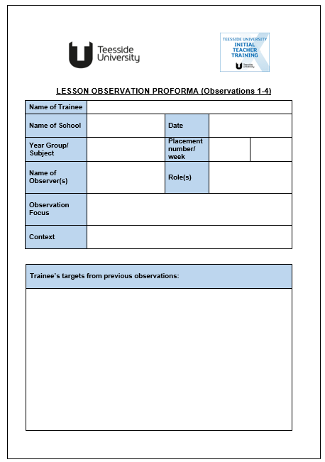
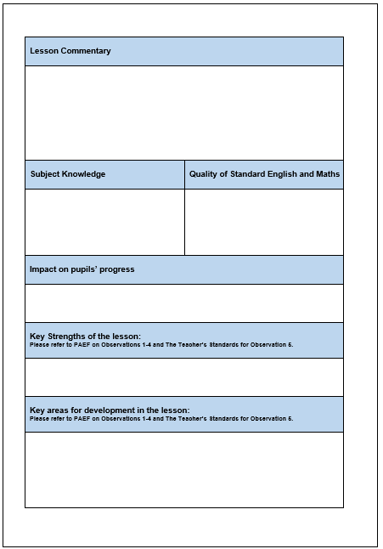



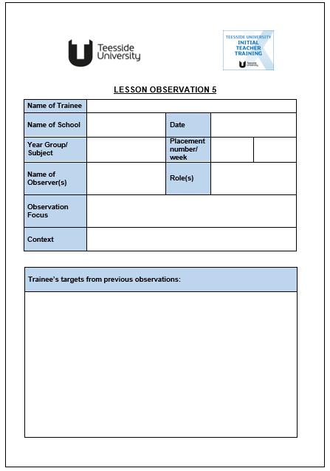

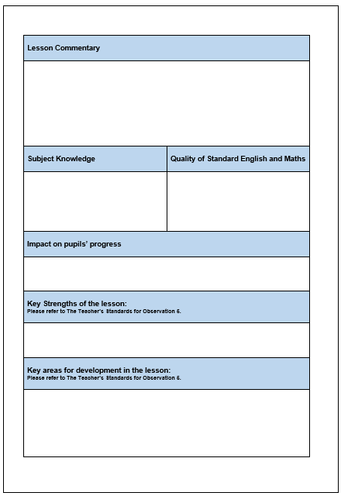



Appendix G
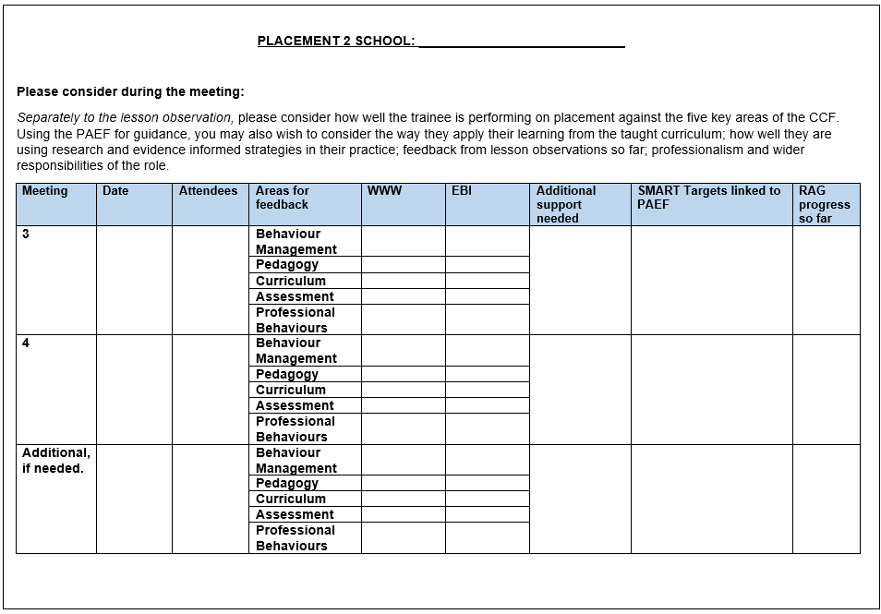
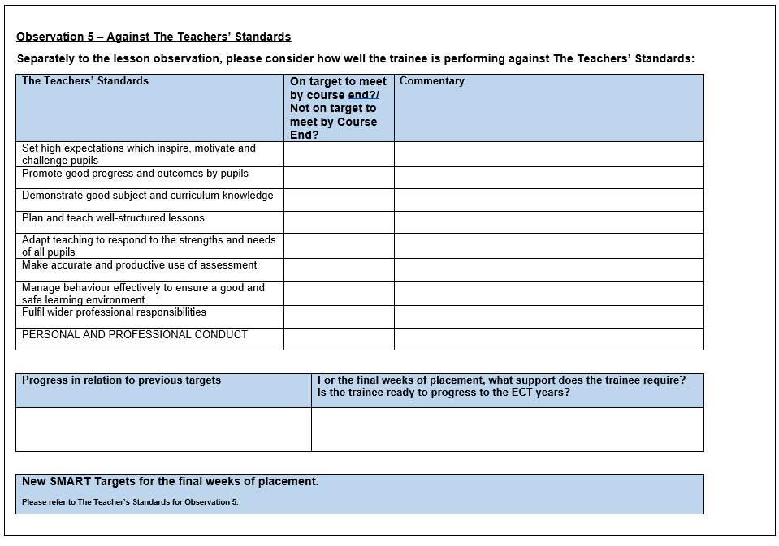

Appendix H




Appendix I




Appendix J


Appendix K


Appendix L

Teesside University Initial Teacher Training (TUITT)

Practice and Academic Enhancement Framework (PAEF)

TUITT Vision: Teesside University’s Initial Teacher Training (TUITT) partnership aims to enable enthusiastic, committed trainees whose inherent curiosity and creativity as life-long learners empower them to become strong, reflective teachers who strive to continually improve their practice.

This framework: This framework is designed to support the assessment of trainees across TU Initial Teacher Training. It captures all aspects of development across the trainee journey including practice, academic study, and continued personal and professional development.
